# Lab Manual 11

# Flip Flops

## Objectives:

To learn and understand the working of Flip Flop

## Flip Flops

A flip-flop is a memory device that samples and acts upon its input lines only when it is told to do so with a special timing signal called the clock. This may be in the form of a level or an edge. The student should understand how a latch or flip-flop works to hold the data and set and reset states.

### D-Type Flip-Flop

This device 7474 contains two independent positive-edge-triggered D-type flip-flops with complementary outputs. The information on the D input is accepted by the flip-flops on the positive going edge of the clock pulse. LOW logic level on the preset or clear inputs will set or reset the outputs regardless of the logic levels of the other inputs.

|  |  |
| --- | --- |
| C:\Users\fast\Desktop\74ls74.png |  |

**JK Flip-Flop**

This device LS76A contains two independent negative-edge-triggered JK-type flip-flops with complementary outputs. The information on the J and K is accepted by the flip-flops on the negative going edge of the clock pulse. LOW logic level on the preset or clear inputs will set or reset the outputs regardless of the logic levels of the other inputs.

|  |  |
| --- | --- |
| Image result for SN7476 |  |

## Problems / Assignments

|  |  |
| --- | --- |
| Problem 1 |  |

Design a positive-edge triggered Master-Slave D-type flip-flop.

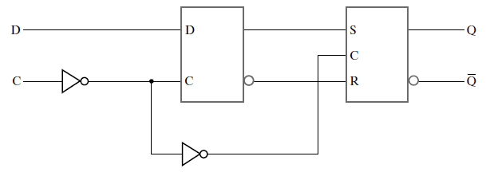

|  |  |
| --- | --- |
| Problem 2 |  |

1. Implement the following using 74_74 component in the Logic Works. The goal over here is to understand the working of the circuit only, understanding the designing is not the part of the exercise.
2. Connect the binary switch with CLK and then replace binary switch with clock generator. Observe the difference between the two approaches. **Note: You have to submit circuit with the binary switch**
3. Observe the timing diagram in Logic Works.
4. Connect the output of the circuit to the hex display on the Logic Works.

**Clock parameter for Logic Works:**

On Time: 1 us

Off Time 1 us

